A

Project Report on

**Voice Assistance and Navigation based Smart Shopping**

Submitted in partial fulfillment of the requirements For the degree of

BACHELOR OF ENGINEERING

IN

### Electronics & Telecommunication Engineering

BY

Devendra Khetade (19103033)

Tejas Kulkarni (19103064)

Aniket Kumbhar (19103012)

Vaibhav Yadav (19103027)

Under the guidance of

## Prof. Mahesh Pawaskar



### Department of Electronics & Telecommunication Engineering

**A.P. Shah Institute of Technology**

**G. B. Road, Kasarvadavali, Thane (W), Mumbai-400615**

**UNIVERSITY OF MUMBAI**

**2022-2023**

## CERTIFICATE

This is to certify that the project entitled **Voice Assistance and Navigation based Smart Shopping** is

a bonafide work of

**Devendra Khetade (19103033)**

**Tejas Kulkarni (19103064)**

**Aniket Kumbhar (19103012)**

**Vaibhav Yadav (19103027)**

submitted to the University of Mumbai in partial fulfillment of the requirement for the award of **Bachelor of Engineering** in **Electronics & Telecommunication Engineering** as laid down by the University of Mumbai during the academic year 2022-23.

( ) ( )

External Examiner-1 Internal Examiner-2

|  |  |  |
| --- | --- | --- |
| ( ) | ( ) | ( ) |
| Prof. Mahesh Pawaskar | Prof. A. M. Deshpande | Dr. U. D. Kolekar |
| Guide | Head of Department | Principal |

### DECLARATION

We declare that this written submission represents our ideas in our own words and where other ideas or words have been included. We have adequately cited and referenced the original sources. We also declare that we have adhered to all principles of academic honesty and integrity and have not misrepresented or fabricated or falsified any idea/data/fact/source in our submission. We understand that any violation of the above will be cause for disciplinary action by the Institute and also can evoke penal action from the source which have thus not been properly cited or from whom proper permission has not been taken when needed.

|  |  |  |  |
| --- | --- | --- | --- |
| **Devendra Khetade** | **Tejas Kulkarni** | **Vaibhav Yadav** | **Aniket Kumbhar** |
| (19103033) | (19103064) | (19103027) | (19103012) |
|  |  |  |  |

### ABSTRACT

### In metropolitan cities, we will see an enormous rush at shopping malls on holidays and weekends. This becomes, even more, once there are large offers and discounts. Currently folks purchase a spread of things and place them within the trolley, after buying one ought to approach the counter for billing. By employing a barcode reader the cashier prepares the bill that may be a time overwhelming method. This ends up in long queues at the billing counters. This project presents a plan to build up a framework in shopping centers to beat the above issue. To realize this all merchandise within the mall to be equipped with RFID tags and every one trolley should be equipped with an RFID reader and digital display screen. This is enhance with the use of voice assistance and navigation.

### ACKNOWLEDGEMENT

We make a move to offer our genuine thanks to **Prof. Mahesh Pawaskar** for his important direction in this task. We are especially appreciative for his untiring help with this project as he had been empowering us in taking out the mistake and kept our advancement on plan.

We are likewise thankful for the co-activity and significant help delivered by **Prof. A.M. Deshpande** as Head of the Department. We might want to offer our unique gratitude to the next instructing and non-showing staff of the EXTC Department for their valuable help in the finish of this task.

At long last, we are enormously obliged to the administration of our school and express our appreciation to the **Principal Dr. Uttam Kolekar** for organizing and giving essential office in finishing this venture work.

We wish to recognize the assistance gave by our kindred schoolmates to aiding the assets while finishing this undertaking. We truly thank all other people who have assisted us in this venture with working.

|  |  |  |  |
| --- | --- | --- | --- |
| **Devendra Khetade** | **Tejas Kulkarni** | **Vaibhav Yadav** | **Aniket Kumbhar** |
| (19103033) | (19103064) | (19103027) | (19103012) |

### LIST OF FIGURES

|  |  |  |
| --- | --- | --- |
| Fig. No. | Name of the Figure | Page No. |
| 1.1 | Smart Trolley | 10 |
| 4.1 | Block Diagram | 20 |
| 4.2 | RFID with NodeMCU Circuit Diagram | 21 |
| 4.3 | Transmitter Circuit for Trolley | 22 |
| 4.4 | Receiver Circuit for Trolley | 22 |
| 4.5 | Audio circuit Diagram with NODEMCU for trolley | 23 |
| 4.2.1 | Arduino Nano | 24 |
| 4.2.2 | NodeMCU (8266) | 24 |
| 4.2.3 | IC-L293D | 25 |
| 4.2.4 | Voltage Regulator 7805 | 25 |
| 4.2.5 | RFID Card Reader | 26 |
| 4.2.6 | BO Motor | 26 |
| 4.2.7 | Battery operated (BO) Wheels | 27 |
| 4.2.8 | Zero PCB | 27 |
| 4.2.9 | Li Ion battery | 28 |
| 4.2.10 | Buzzer | 28 |
| 4.2.11 | DF Player mini-MP3 | 29 |
| 4.2.12 | Audio Amplifier | 29 |
| 4.2.13 | NRF24L01 | 30 |
| 4.2.14 | MPU6050 | 30 |
| 5.1 | Home Page of Website | 33 |
| 5.2 | Upcoming Event Page | 33 |
| 5.3 | Festival Sale page | 34 |
| 5.4 | Offers | 34 |

|  |  |  |
| --- | --- | --- |
| 5.5 | Branches Page of Website | 35 |
| 5.6 | Navigation Page of Website | 35 |
| 5.7 | Map of the shop | 36 |
| 5.8 | About Us page of website | 36 |
| 5.9 | Our Mission | 37 |
| 5.10 | Publisher information page | 37 |
| 5.11 | Contact info | 38 |
| 5.12 | Registration page | 38 |
| 5.13 | Registration Successful | 39 |
| 5.14 | Login Page | 39 |
| 5.15 | Shopping List page | 40 |
| 5.16 | Google sheet Register Page | 40 |
| 5.17 | Google sheet Login page | 41 |
| 518 | Google sheet Contact us Page | 41 |
| 5.19 | Google Sheet Final Page | 42 |
| 5.20 | XAMPP control Panel | 43 |
| 5.21 | XAMPP Admin page | 43 |
| 5.22 | Interfacing of Node MCU with RFID | 44 |
| 5.23 | Shopping Cart Front View | 45 |
| 5.24 | Shopping Cart Top View | 46 |
| 5.25 | Navigation Transmitter | 47 |

**INDEX**

CHAPTER 1 9

1.1 Introduction 10

CHAPTER 2 11

* 1. Literature Survey 12
     1. History 12
     2. Review 16
     3. Research Gap 18

CHAPTER 3 19

* 1. Problem Statement 20

CHAPTER 4 21

* 1. System design 22
  2. Working of Shopping Cart 23
  3. Tools Implemented 26

CHAPTER 5 33

* 1. Results 33
  2. Application Output 34
  3. Output 46

CHAPTER 6 49

* 1. Conclusion 50
  2. Future Scope 51

CHAPTER 7 52

* 1. References 53

### CHAPTER 1

### INTRODUCTION

### INTRODUCTION

In this rapidly changing era, the innovation of technologies evolves at an exponential rate. Many companies are investing into developments which ensure satisfaction for all stages of consumers. One of the most common developments is technologies in customer service which promises new and robust systems for shoppers. Shopping carts, which are also commonly known as shopping trolleys are a method of transportation of goods temporarily before cashing out. Shopping carts have limited changes made since its invention. Most of the expansions have been done is to modify its capacity and weight. However, due to the improvement of technology, some of the company’s research have been developed a convenient shopping system to customer. For example, there is a touch panel and bar code scanner attached on the shopping trolley, the customer can be informed about the promotion and location of goods from the touch panel. Besides that, the bar code scanner will scan the purchasing item when the customer place it into the trolley, and the amount of the bill will be displayed on the touch panel display. The customer will just have to perform the payment based on the amount on the display to the cashier without the long queue of payment procedure. The improvement of shopping cart as mentioned can save shopping time of customer, but it requires manually navigation by the customer. Therefore, the purpose of this project is to allow hands free shopping experience to the customer, so that the need of self-driven and artificial intelligence shopping trolley is inevitable.

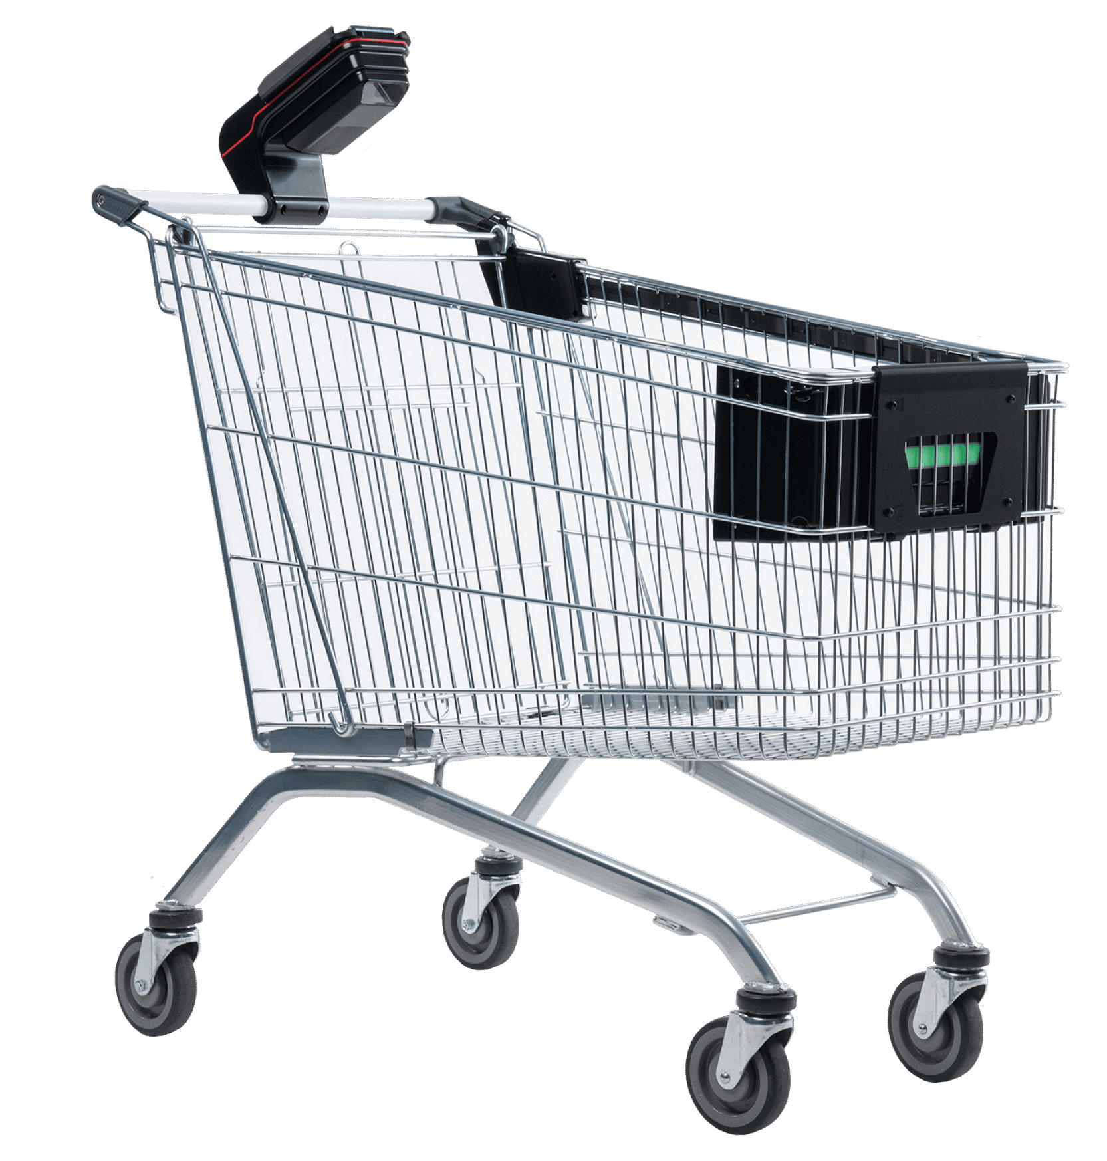

### Fig 1.1: Smart Trolley

### CHAPTER 2

### LITERATURE SURVEY

1. **LITERATURE SURVEY**
   1. **Smart electronic trolley for shopping mall:**

It is wireless techniques along with one more communication technology has helped in making electronic commerce very popular. In this paper we discuss on innovative concept of “Smart Electronic shopping Trolley used in commercial complex which many individual retail stores. The main purpose here is to assist a person in shopping to reduce time while purchasing a product. Electronic trolley is fitted out with Barcode reader that scans the identification of outcome and internet connection with shop’s server. It is also consisting of LCD exhibits that notify the number of items and total amount to customers and Barcode scanner identifies the outcome and updates the bill. Swiping machine will be provided to recompense the bill through credit/debit cards. In this paper, we report the performance or administration of reliable and more efficiency smart trolley shopping using WSN such a trolley is acceptable for supermarkets, it can help in reducing manpower and creating better shopping occurrence for customers. [1]

* 1. **Smart Trolley for smart Shopping:**

Shopping is really fascinating and alluring; at the same time, it involves getting tired due to standing in a long queue for the bill and payment process. Hence, it is proposed to design a smart trolley which can take care of shopping and billing. By this, the customer can walk straightaway into the shop, purchase products using the smart trolley and walk out of the shop. He gets the e-bill through the mail, and he can view his purchase details using the shop’s website. In order to realize this, we need an Arduino board, Radio-Frequency Identification (RFID) reader, RFID tag, LCD display, ESP8266 Wi-Fi module, database manager and a website to maintain product and customer details, which can be accessed by the admin anywhere in the world. This is an IOT based system where the trolley can interact with the network spread worldwide. [2]

* 1. **Iot based smart shopping cart using Radio Frequency Identification:**

The modern age of technology in which most of the customer needs to wait in the supermarket for shopping because it is a highly time-consuming process. A huge crowd in the supermarket at the time of discount offers or weekends makes trouble to wait in long queues because of a barcode-based billing process. In this regard, the Internet of Things (IoT) based Smart Shopping Cart is proposed which consists of Radio Frequency Identification (RFID) sensors, Arduino microcontroller, Bluetooth module, and Mobile application. RFID sensors depend on wireless communication. One part is the RFID tag attached to each product and the other is RFID reader that reads the product information efficiently. After this, each product information shows in the Mobile application. The customer easily manages the shopping list in Mobile application according to preferences. Then shopping information sends to the server wirelessly and automatically generates billing. This experimental prototype is designed to eliminate time-consuming shopping process and quality of services issues. The proposed system can easily be implemented and tested at a commercial scale under the real scenario in the future. That is why the proposed model is more competitive as compared to others**.**[3]

* 1. **SMART-Mobile Autonomous Robotic Trolley:**

Shopping malls and complex are increasing day by day and can see an enormous surge at these shopping centres on the siestas and ends of the weeks. Consumers buy different products and place them in trolley. After selecting all the products, one needs to go cashier counter for billing of the products. At the billing counter, the cashier prepares the bill by scanning the bar code of each product which is an exceptionally tedious process and results in a long queue at the billing counter. In this paper, a prototype of Smart Mobile Autonomous Robotic Trolley (SMART) is proposed for helping a consumer for shopping in terms of reduction in shopping time and analysing the products in the view of total billing and expiry date. The primary aim of the proposed prototype is to reduce this tedious process, use minimal effort for shopping concept and reduce the time of both customers and salespeople. In the implemented system, ATmega 16 microcontroller is interfaced with EM18 RFID reader module, buzzer, and LED indicator. Wireless data transfer between the trolley billing system and billing station system is achieved through XBee ZigBee S2D. The key aspects of the overall system consisting of the system architecture, trolley billing system, product detection system, trolley controlling system methodology, power supply. The system also implements an algorithm for shopping controlling system, trolley controlling system. The proposed prototype consists of two parts, the first part includes RFID based product detection, bill generation, wireless communication between shopping trolley with billing counter using ZigBee and second part consist of control motion of trolley using customer control which also includes obstacle detection. The detailed hardware-software implementation is discussed in this paper.[4]

* 1. **Human friendly smart trolly with automatic billing system:**

Shopping and buying is an integral part of our daily lives. Big mega markets have a wide variety of items and different stores can have different deliveries of goods. It is difficult for many consumers to stand in the long queue for the billing of goods purchased. This causes a wastage of money and a poor bill for the wrong customer. Trolleys are used in supermarkets or grocery stores to make shopping simpler. However, it is difficult for customers to control the trolley while shopping. An automated customer following trolley was implemented which calculates the total sum of grocery items carried in the trolley by the customers. This reduces the customer's effort to pull the trolley and keep the line for the payment of the grocery products. The customer who has a specific tag and a web camera installed in front of the trolley will recognize the tag and move the trolley to the customer. Using the RFID tag and the Raspberry Pi receiver, the item bill inserted has been obtained in the trolley. This results in an ideal solution to all these problems.[5]

* 1. **Smart trolley:**

On holidays and weekends, usually we see a huge rush especially in the metro cities. Huge offers and discounts make more rush in markets. In shopping malls, normally we get a trolley in which we put all the items intended to be purchased from different shelves.

After putting all items in trolley, we approach the counter for billing and it results in long queues at counter. This project presents a solution to these long queues. To fulfil this, a barcode reader and a LCD screen are attached to the trolley. The barcode automatically detects the barcode on the product when we put the item in the trolley and with the help of a screen, the item details will be displayed. In this way the cost of the item gets added to bill. By this practice trolley will itself do all the billing and problem of long queue on counters will be solved.[6]

* 1. **Automated billing smart trolley:**

In this modern world, all people like to use products which is of high technology.

People do not want to waste time and energy by using conventional systems. Rather they prefer advanced devices which is automated, smart, to finish their work soon. Smart trolley is one such advanced devices which is more flexible and a easy process to complete shopping without any delay. Customers in the store do not want to wait for long time to pay their bill. In the smart trolley the bill can be paid simultaneously without waiting in the counter. Once the shopping is over payment is done through online or offline based on the customer. This flexibility is not provided by

the existing trolley. To overcome this, Smart trolley is preferred. The newly designed smart trolley consists of Arduino UNO, RFID reader and tag, Wi-Fi module. Apart from this payment feature, s mart trolley allows the admin to view the stock details also. Each product’s stock can be monitored and planned accordingly without any extra manual work.[7]

* 1. **Iot based smart shopping trolley with mobile cart application:**

Even through e-commence and other online applications are growing rapidly the craze for traditional shopping has never stepped back. One difficulty is to follow up in a queue for the billing process. There, arises a demand for easy and quick payment of bills. The proposed Smart Cart in this paper, is capable of generating bill using IoT along with the mobile cart application. With the use of this mobile application and trolley, customer can make bill payment in no time. The smart cart uses the RFID tag and receiver to scan the product, load cell to prevent theft, LCD display and the Raspberry p i Along with this the customer can also log in with the mobile app which will display the list of all the

products mentioned and their amount. Once done, the customer can pay the bill through the mobile application.[8]

* 1. **RESEARCH GAP:**

The first paper presents on innovative concept of Smart Electronic shopping Trolley used in commercial complex which many individual retail stores. Second paper concentrates on designing a smart trolley which can take care of shopping and billing. Third paper discusses the Internet of Things (IoT) based Smart Shopping Cart is proposed which consists of Radio Frequency Identification (RFID) sensors, Arduino microcontroller, Bluetooth module, and Mobile application. In fourth paper it mentions about a prototype of Smart Mobile Autonomous Robotic Trolley (SMART) is proposed for helping a consumer for shopping in terms of reduction in shopping time and analyzing the products in the view of total billing and expiry date. Fifth paper explains an automated customer following trolley was implemented which calculates the total sum of grocery items carried in the trolley by the customers. Sixth paper tells us about a solution to these long queues. To fulfill this, a barcode reader and a LCD screen are attached to the trolley. Seventh paper talks about the newly designed smart trolley consists of Arduino UNO, RFID reader and tag, Wi-Fi module. Apart from this payment feature, smart trolley allows the admin to view the stock details. Eighth paper gives an explains that the proposed Smart Cart in this paper, is capable of generating bill using IoT along with the mobile cart application. Taking inspiration from literature survey done, we have incorporated a few ideas of our own. We have added voice assistance which benefits largely to users. We have also added a navigation feature for ease of use and convenience. We have generated a website and incorporate all the features together which wasn’t done before.

### CHAPTER 3

### PROBLEM STATEMENT

### PROBLEM STATEMENT

Human error and/or carelessness of the customer while control their trolley may cause incidents to happen. The problem with such system is that it can scan only a single product at a given time. This consumes a lot of time during the billing process. For example, consider a queue as in figure. Here, if the first person has 20 products in his cart and second person has 15 products but the third person has to buy just a single item, he will have to wait for much more time than he needs to be taken at the counter due to the people ahead of him. This wastes a lot of time of the person as well as of the other people behind him and the store authorities. So, we have come across a far better solution through our project which helps in effective time management during scanning and creating the bill during checkout.

The solution for these problems is:

1. By using the RFID technology, we can scan multiple items at a given time. RFID Reader/Writer is mounted upon the cart which scans Real Time objects placed inside the cart and displays the total amount upon the LCD mounted on the trolley thus reducing the total time taken by any person during checkout.
2. The second objective is to help the elderly as well as the handicapped people to move the trolley easily without even needing to push it. We use the encoder decoder and RF module which is placed in the remote and the person can remotely control the cart. This frees the customer of the burden to push heavy trolleys around the shopping mall.

### CHAPTER 4

### SYSTEM DESIGN

### &

### WORKING

### 4.1 SYSTEM DESIGN & WORKING



**Figure 4.1:** Block Diagram overall workflow of Application

**Block Description**

* A data is stored in RFID card and is scanned through RF reader.
* NodeMCU (ESP8266) is connected to RF reader where a programming is done to write and read data.
* A Buzzer is there which beeps that indicates a card is scanned.
* A Google sheet is allocated to store all data which is scanned and that is connected to NodeMCU through Internet.
* As soon as you scan a card, you will hear beep sound & at the same time you will hear the audio of the data.
* The same data will be stored in google sheet & it will be visible on website.

**Working:**

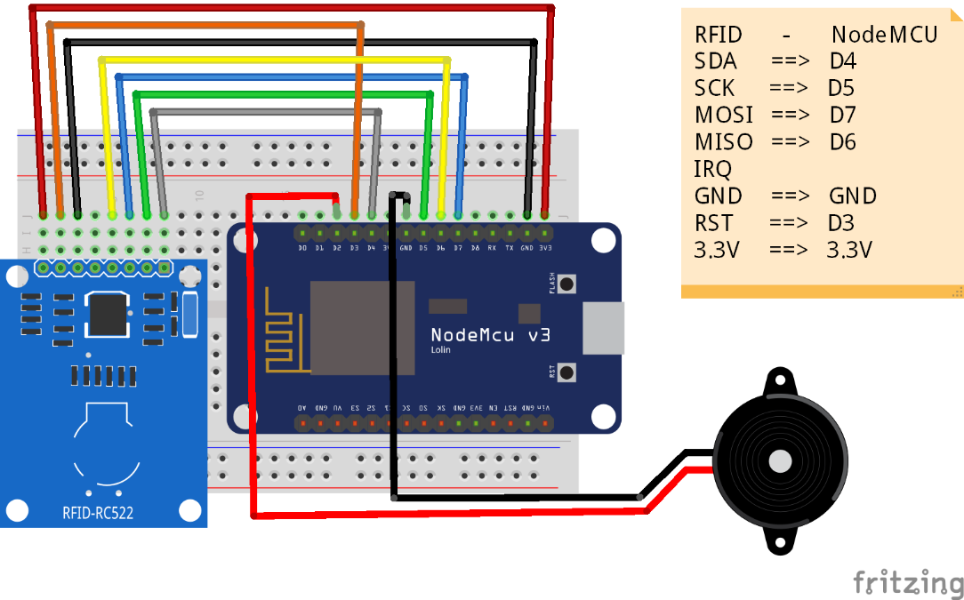

**Fig 4.2** RFID with NODEMCU

First, we must mount the components on pcb board and make the connection according to the given fig above. Make sure that we had made a proper connection for each pin. Connect the Nodemcu module to computer or Laptop using USB cable. Then by using Arduino IDE software first we must write and upload code in NodeMCU module for writing data in RFID Card, for writing the data in RFID Card we have to scan it on RF Reader. A beep Sound we will hear which indicate that RFID Card is scanned. Hold the card for two-three seconds for writing the data in card properly. Note that data must be written in card successfully. If fails repeat the procedure again to write data. Once data is written in RFID Card now again, we have to write code for sending the data to Google sheet for that we have to connect Google sheet to Nodemcu by using URL through Internet as this code is uploaded in NodeMCU we have to check whether the Google sheet is connected to module or not. When it is successfully connected, you can scan the RFID Card and again you will hear beep sound for Card is scanned and can be able to store the data in Google sheet. Check the Google sheet whether the data written in RFID Card and data read by RF Scanner which is stored in google sheet are same. Using the above procedure according to the requirement for our project we have written data for Product Id, Product Name, Product cost in RFID Card on which scanning by RF reader the data entered or written and data read are same and is stored in Google sheet.

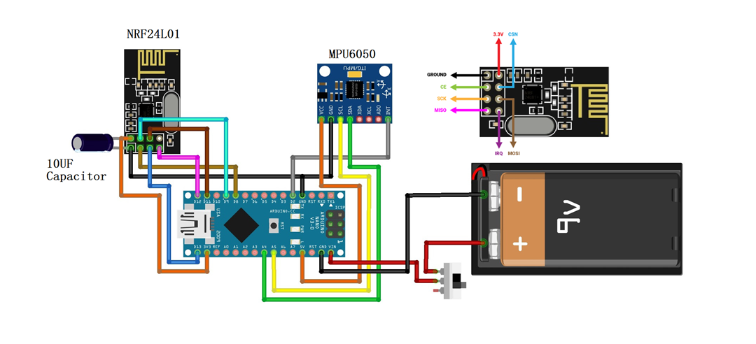

**Fig 4.3** Transmitter Circuit for Trolley

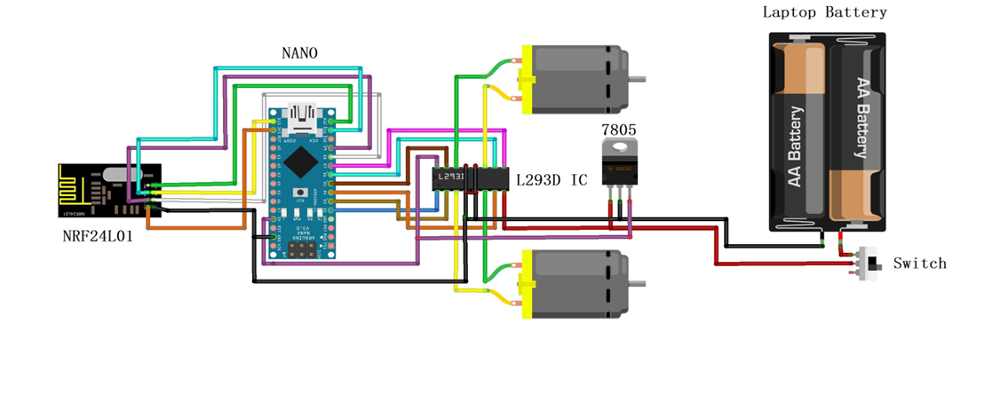

**Fig 4.4** Receiver Circuit for Trolley

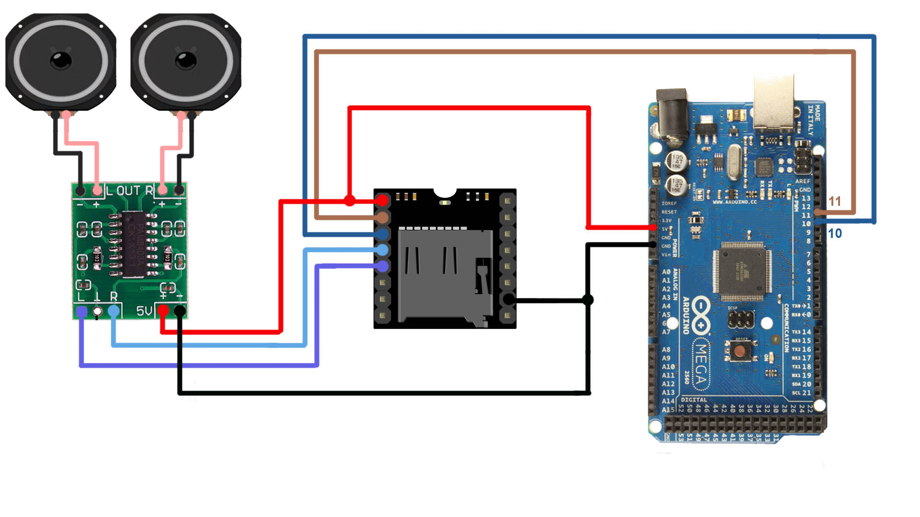

Fig 4.5 Audio circuit Diagram with NODEMCU for trolley

4.2 TOOLS TO BE USED

4.2.1 HARDWARE

1. **Arduino Nano: -**

The Arduino Nano is a small, complete, and breadboard-friendly board based on the ATmega328 (Arduino Nano 3.x). It lacks only a DC power jack, and works with a Mini-B USB cable instead of a standard one.

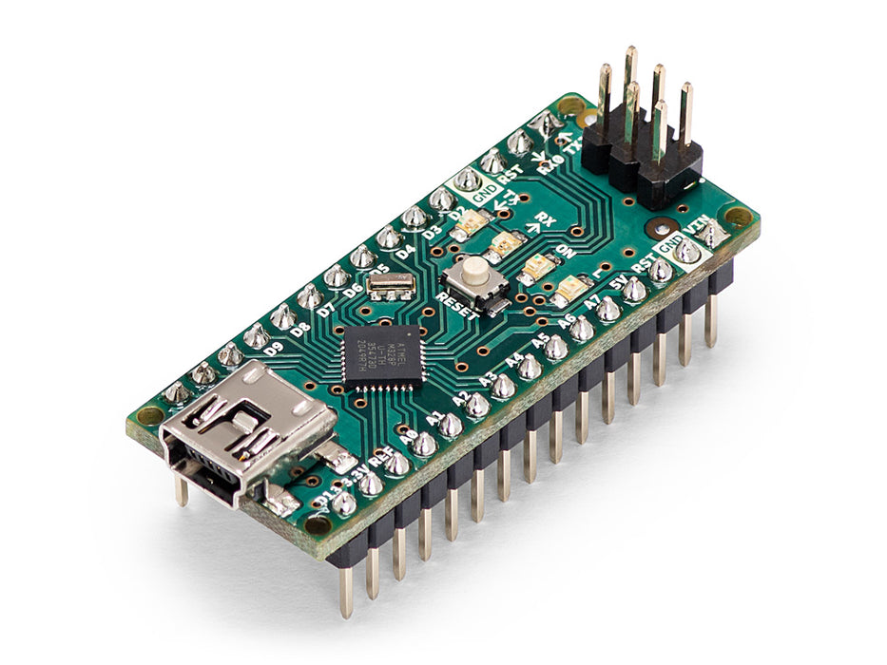

**Fig. 4.2.1:** Arduino Nano

1. **NodeMCU (ESP8266): -**

NodeMCU is an open-source LUA based firmware developed for the ESP8266 WIFI chip. By exploring functionality with the ESP8266 chip, NodeMCU firmware comes with the ESP8266 Development board/kit i.e. NodeMCU Development board.

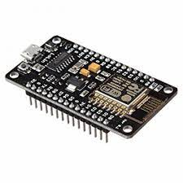

**Fig.** **4.2.2:** NodeMCU (8266)

1. **IC-L293D: -**

The L298 is an integrated monolithic circuit in a 15-lead Multiwatt and PowerSO20 packages. It is a high voltage, high current dual full-bridge driver designed to accept standard TTL logic levels and drive inductive loads such as relays, solenoids, DC and stepping motors.

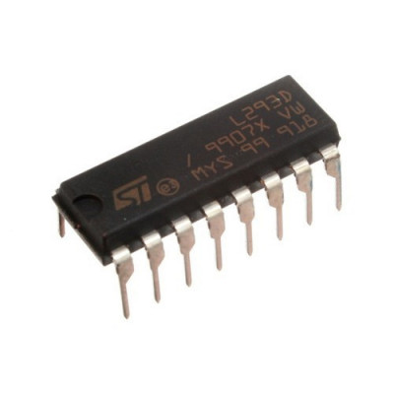

**Fig. 4.2.3:** IC-L293D

1. **VOLTAGE REGULATOR 7805:-**

7805 IC is an iconic regulator IC that finds its application in most of the projects. The name 7805 signifies two meaning, “78” means that it is a positive voltage regulator and “05” means that it provides 5V as output. So our 7805 will provide a +5V output voltage. The output current of this IC can go up to 1.5A. But, the IC suffers from heavy heat loss hence a Heat sink is recommended for projects that consume more current.

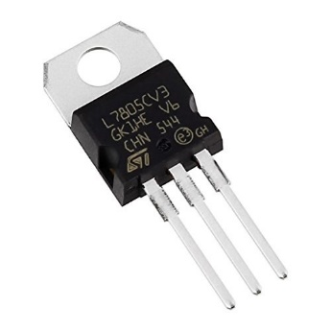

**Fig. 4.2.4** VOLTAGE REGULATOR 7805

1. **Radio Frequency Identification (RFID) Card Reader: -**

The RFID reader is a network-connected device that can be portable or permanently attached. It uses radio waves to transmit signals that activate the tag. Once activated, the tag sends a wave back to the antenna, where it is translated into data. The transponder is in the RFID tag itself.

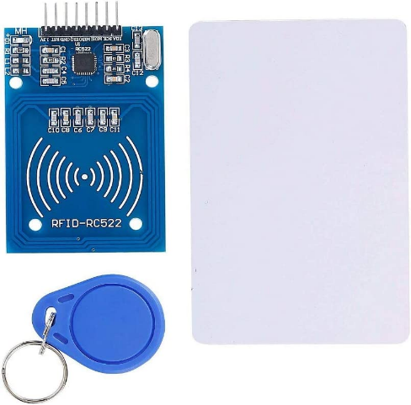

**Fig. 4.2.5:** Radio Frequency Identification (RFID) Card Reader

1. **BO Motor: -**

Bo motor (Battery Operated) lightweight DC geared motor which gives good torque and rpm at lower voltages. Here you can get bo motor with varying rated speed. This motor can run at approximately 200 rpm when driven by a single Li-Ion cell.

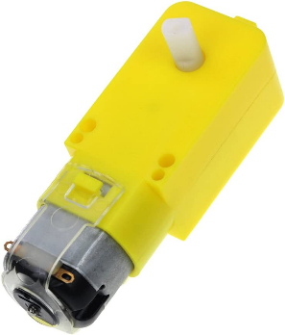

**Fig. 4.2.6:** BO Motor

1. **BO Wheels: -**

High quality plastic wheels for robot, easy to mount and these wheels have 6mm holes for BO gear motor for fitting it and easy to mount on motors.

It has diameter of 6.5cm and width of 2.5cm with a hole diameter of 6mm

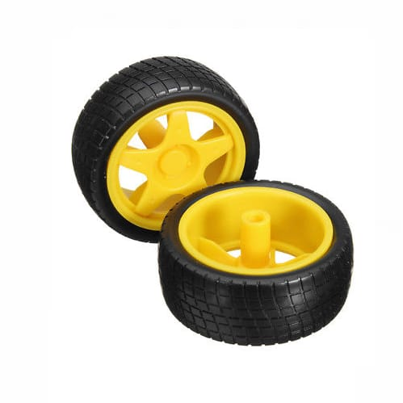

**Fig. 4.2.7:** BO Wheels

1. **Zero Printed Circuit Board (PCB): -**

Zero PCB is basically a general-purpose printed circuit board (PCB), also known as perfboard or DOT PCB. It is a thin rigid copper sheet with holes pre-drilled at standard intervals across a grid with 2.54mm (0.1-inch) spacing between holes

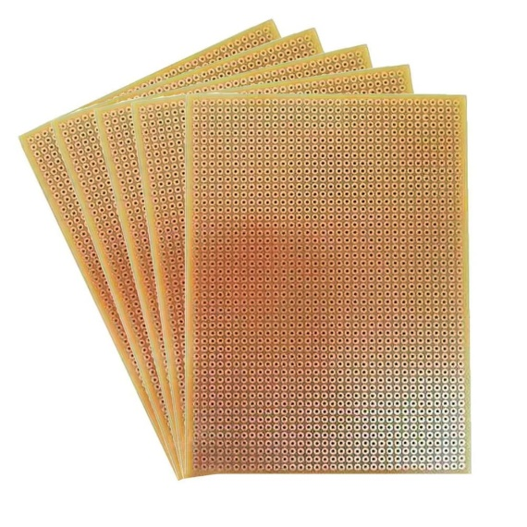

**Fig. 4.2.8: Zero Printed Circuit Board (PCB)**

1. **Li ion Battery: -**

A lithium-ion battery or Li-ion battery is a type of rechargeable battery composed of cells in which lithium ions move from the negative electrode through an electrolyte to the positive electrode during discharge and back when charging According to our project we require voltage of 12v so by arranging li ion battery in series of 3v 2000mah we will get 12v



**Fig. 4.2.9:** Li ion Battery

1. **Buzzer: -**

A buzzer or beeper is an audio signaling device, which may be mechanical, electromechanical, or piezoelectric (piezo for short). Typical uses of buzzers and beepers include alarm devices, timers, train and confirmation of user input such as a mouse click or keystroke

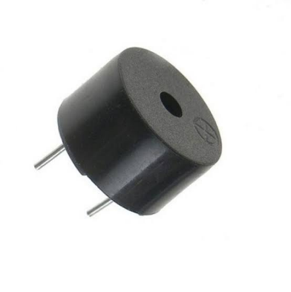

**Fig. 4.2.10**: Buzzer

1. **DF player mini-MP3: -**

DF Player mini-MP3 player is a small and low-cost MP3 module player with a simplified output directly to the speaker. The module can be used as a standalone module with attached battery, speaker and push buttons or used in combination with an Arduino UNO or any other with RX/TX capabilities.

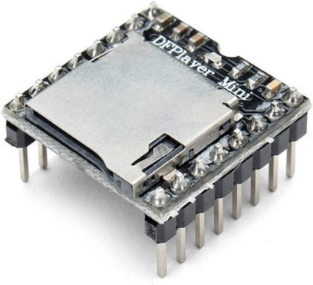

**Fig. 4.2.11** DF Player Mini-MP-**3**

1. **Audio Amplifier :-**

Amplifier is a basic component of all the voice systems available in market. The need of this intermediate circuitry exists so that we can hear crystal clear voice from the voice systems.

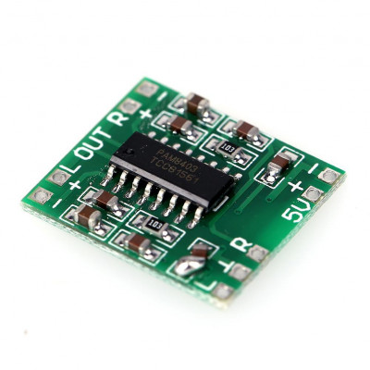

**Fig. 4.2.12** Audio Amplifier

1. **NRF24L01**

The nRF24L01 module is designed to operate in the 2.4 GHz worldwide ISM frequency band and uses GFSK modulation for data transmission. The data transfer rate is configurable and can be set to 250kbps, 1Mbps, or 2Mbps. The module’s operating voltage ranges from 1.9 to 3.9V. Please keep in mind that powering the module with 5V will most likely damage your nRF24L01 module. The output power of the module can be programmed to be 0 dBm, -6 dBm, -12 dBm, or -18 dBm. At 0 dBm, the module consumes only 12 mA during transmission, which is less than the consumption of a single LED.

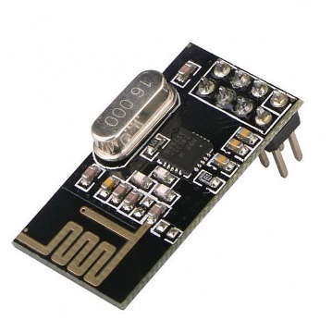

**Fig. 4.2.13** NRF24L01

1. **MPU6050**

MPU6050 is a three-axis accelerometer and three-axis gyroscope Micro Electro-mechanical system (MEMS). It aids in the measurement of velocity, orientation, acceleration, displacement, and other motion-related features. The MPU6050 devices combine a 3-axis gyroscope and a 3-axis accelerometer on the same silicon together with an onboard Digital Motion Processor (DMP) capable of processing complex 9-axis MotionFusion algorithms

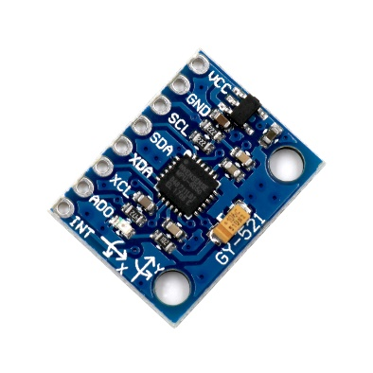

**Fig. 4.2.14** MPU6050

### SOFTWARE

1. **Arduino IDE:**



The Open-source Arduino Software (IDE) makes it easy to write code and upload it to the board. This software can be used with any Arduino board. We are using this software to write code and upload it on our Node MCU board.

1. **Wordpress.com**



WordPress.com allows you to build a website that meets your unique needs. Start a blog, business site, portfolio, online store, or anything else you can imagine. With built-in optimization and responsive, mobile-ready themes, there’s no limit to who you can reach with your new website. Create a simple website for your family or sell products around the world.

1. **XAMPP Server**



XAMPP is a free and open-source cross-platform web server solution stack package developed by Apache Friends, consisting mainly of the Apache HTTP Server, MariaDB database, MySQL and interpreters for scripts written in the PHP and Perl programming languages. It provides localhost for creating website.

### CHAPTER 5

### RESULT

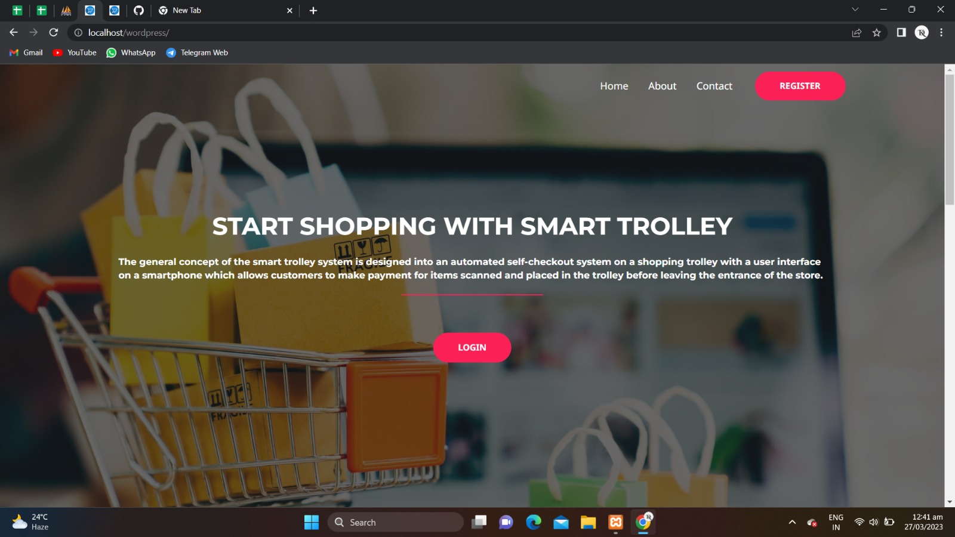

**Fig.5.1 Home Page of Website**

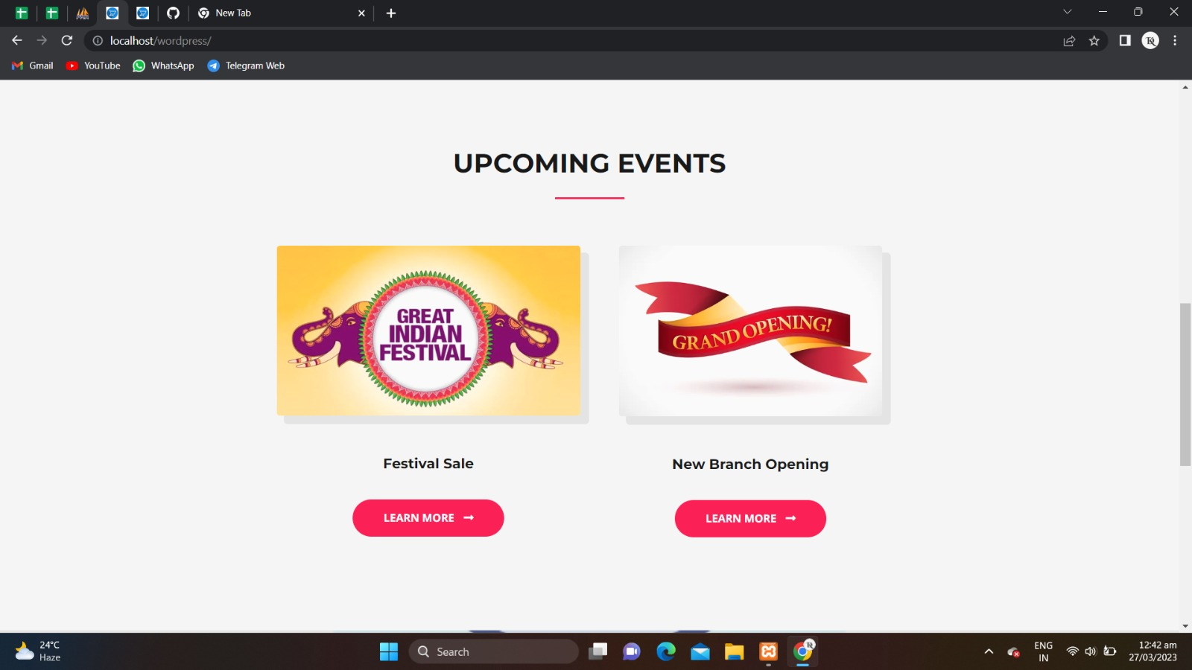

**Fig 5.2 Upcoming Events page**

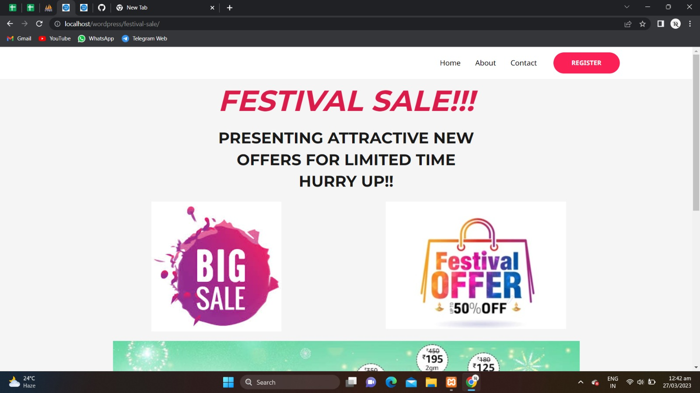

**Fig. 5.3 Festival Sale page**

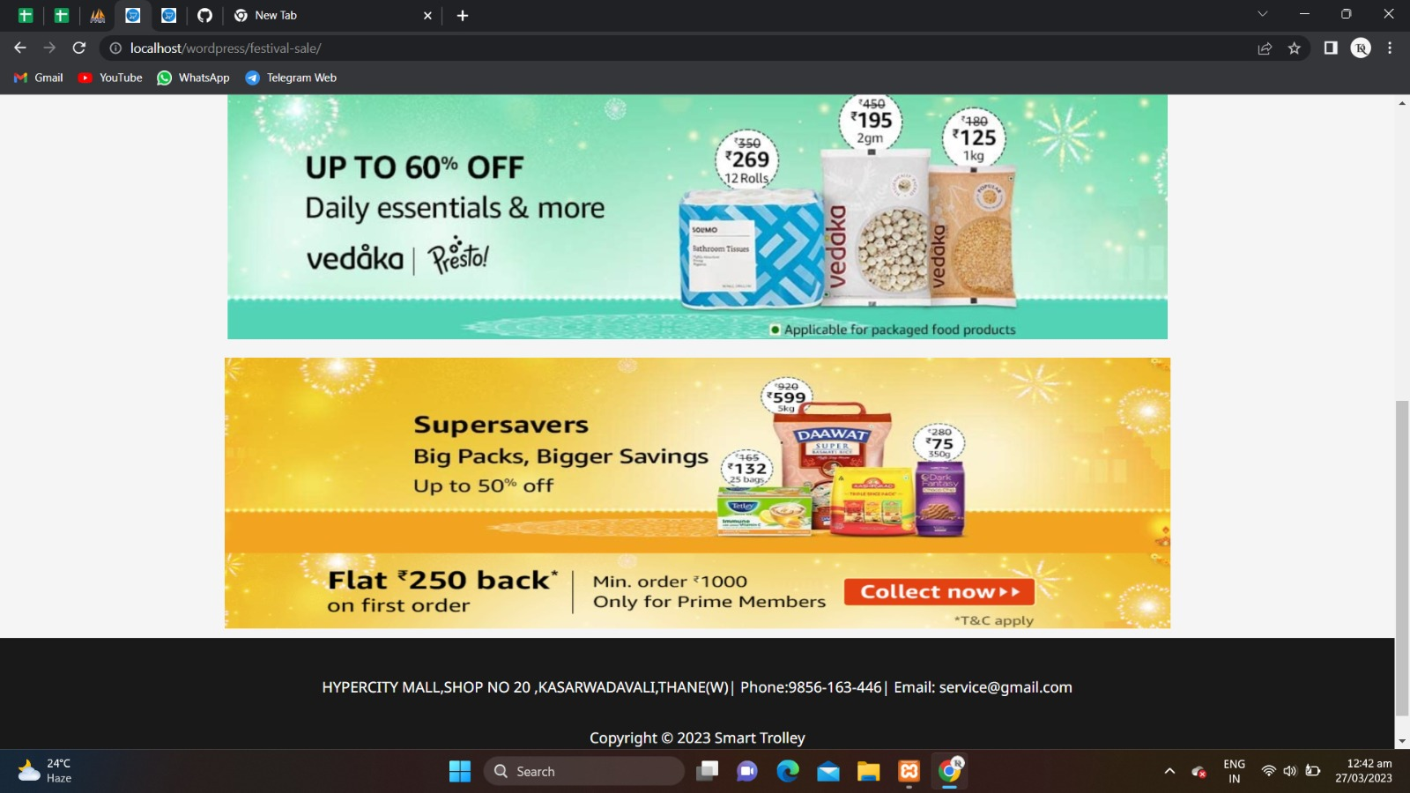

**Fig 5.4 Offers**

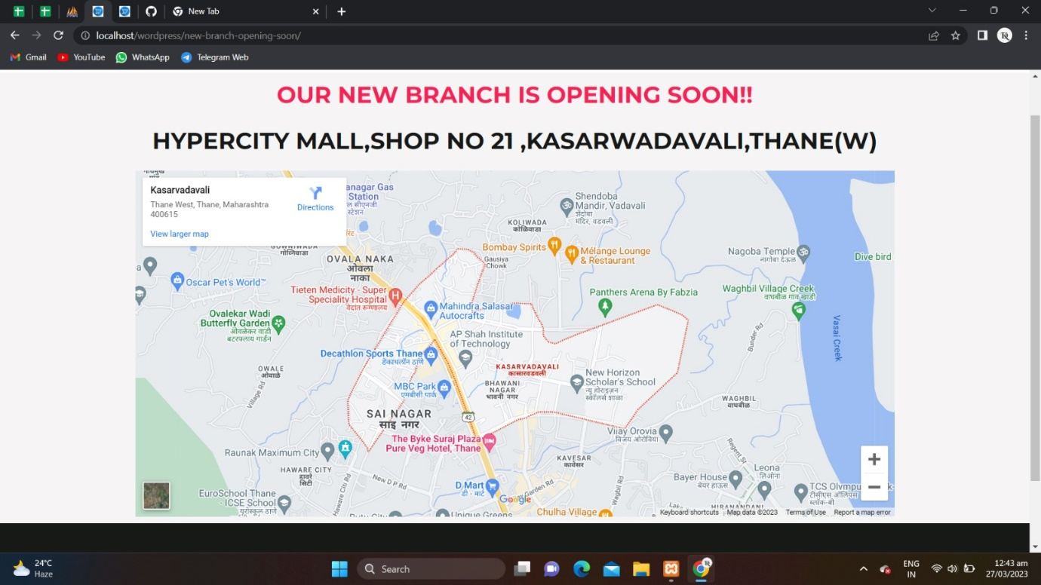

**Fig.5.5 Branches page of Website**

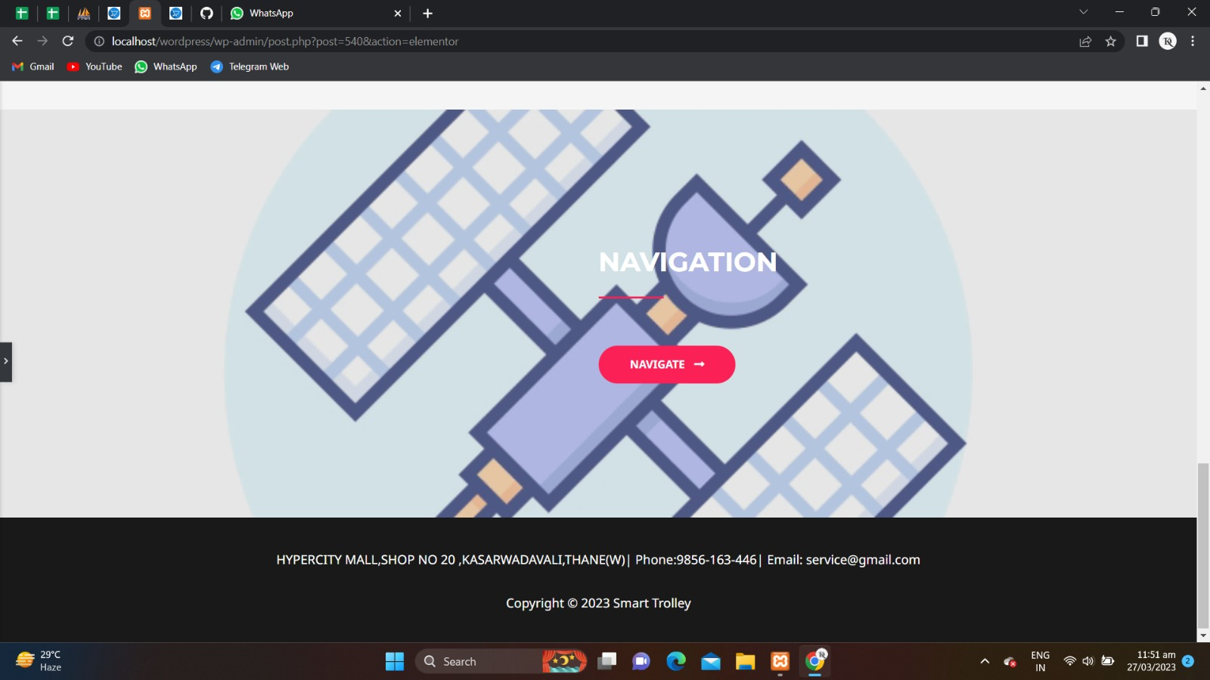

**Fig.5.6 Navigation page of Website**

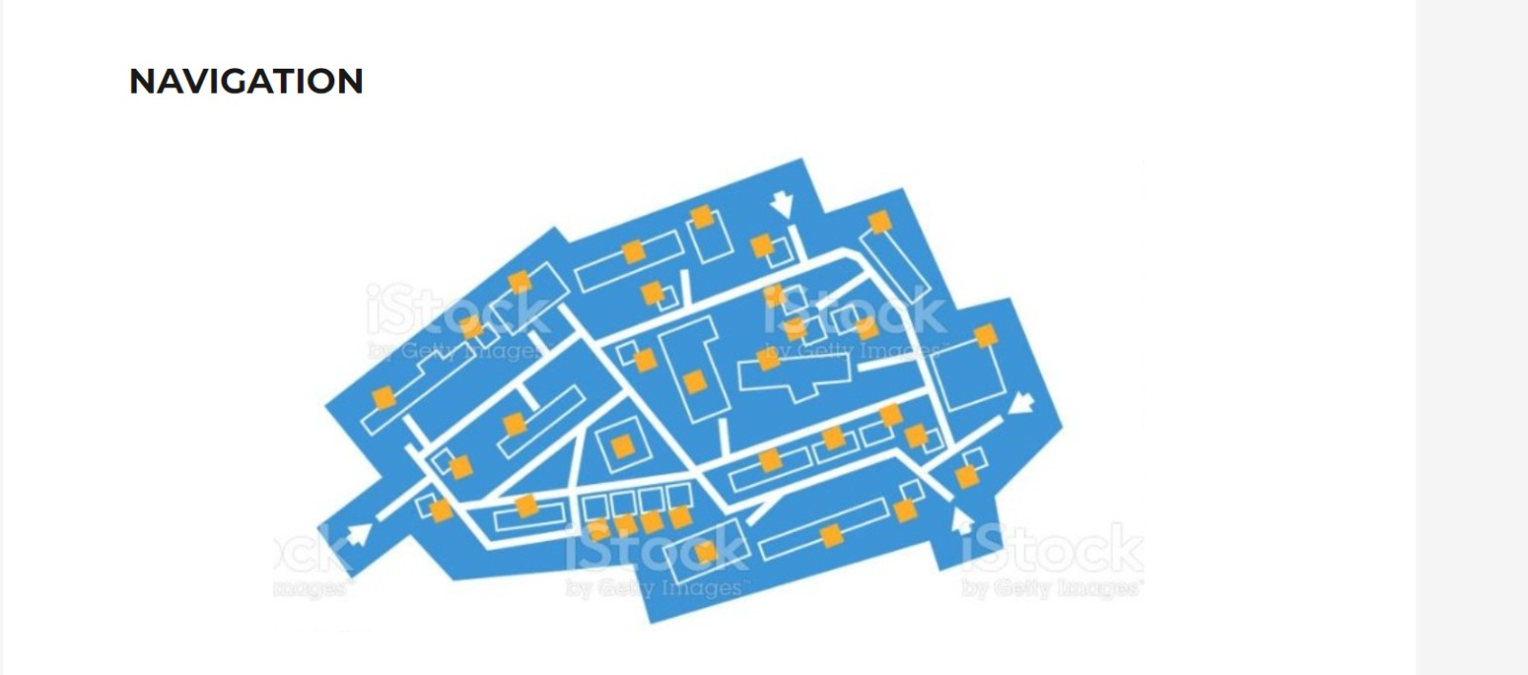

**Fig.5.7 Map of the shop**

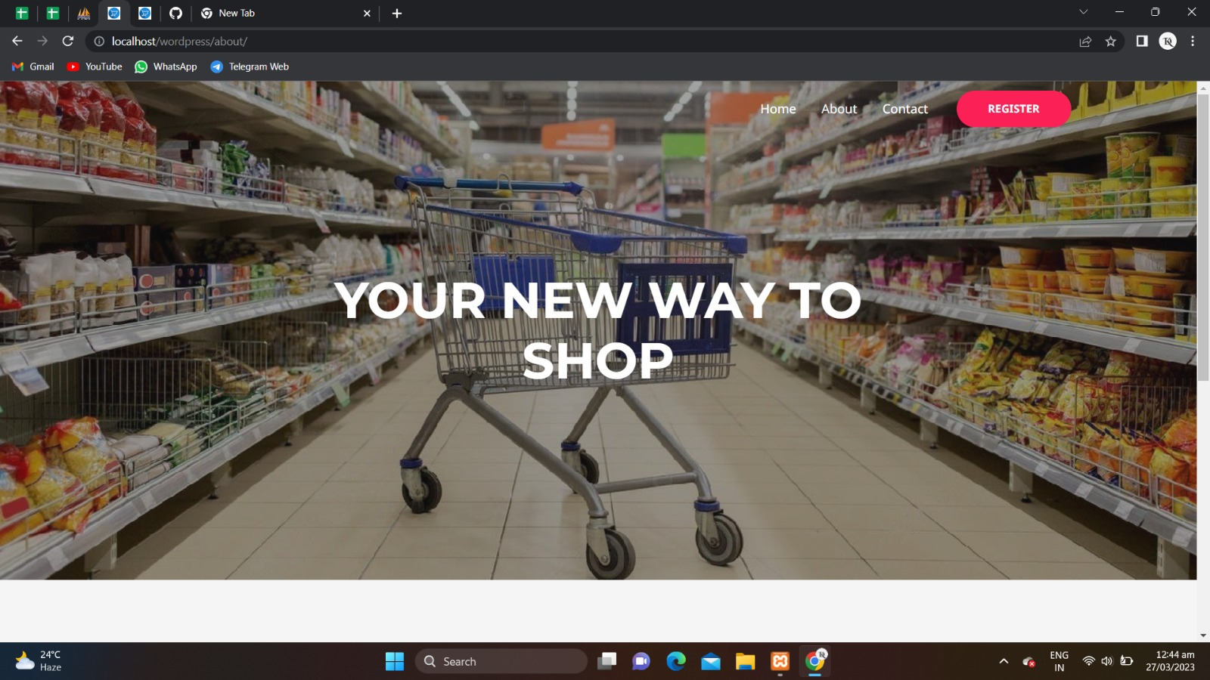

**Fig.5.8 About us page of Website**

### 

**Fig.5.9 Our Mission**

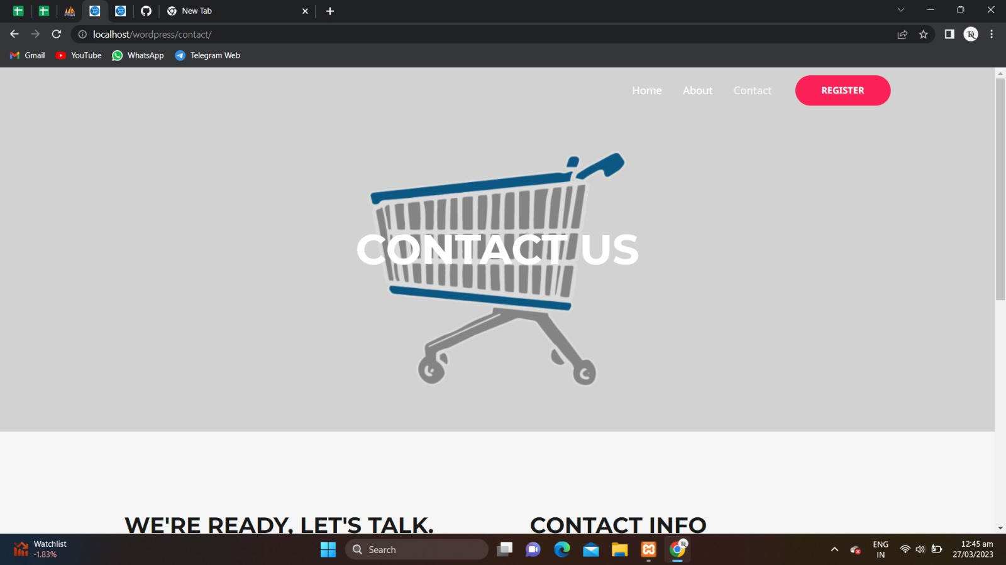

**Fig.5.10 Publisher Information Page**

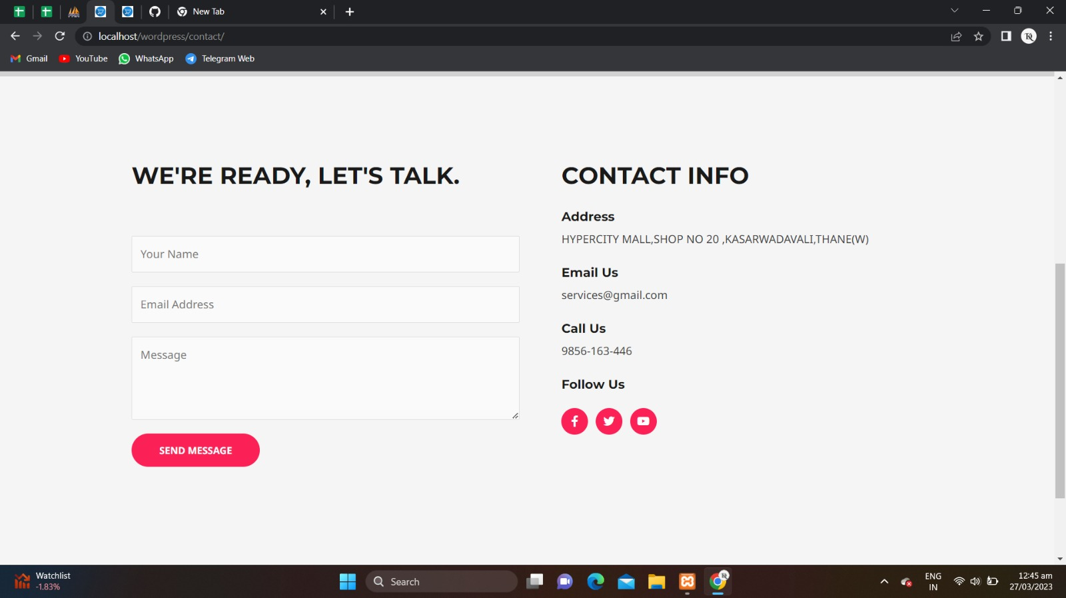

**Fig.5.11 Contact Info**

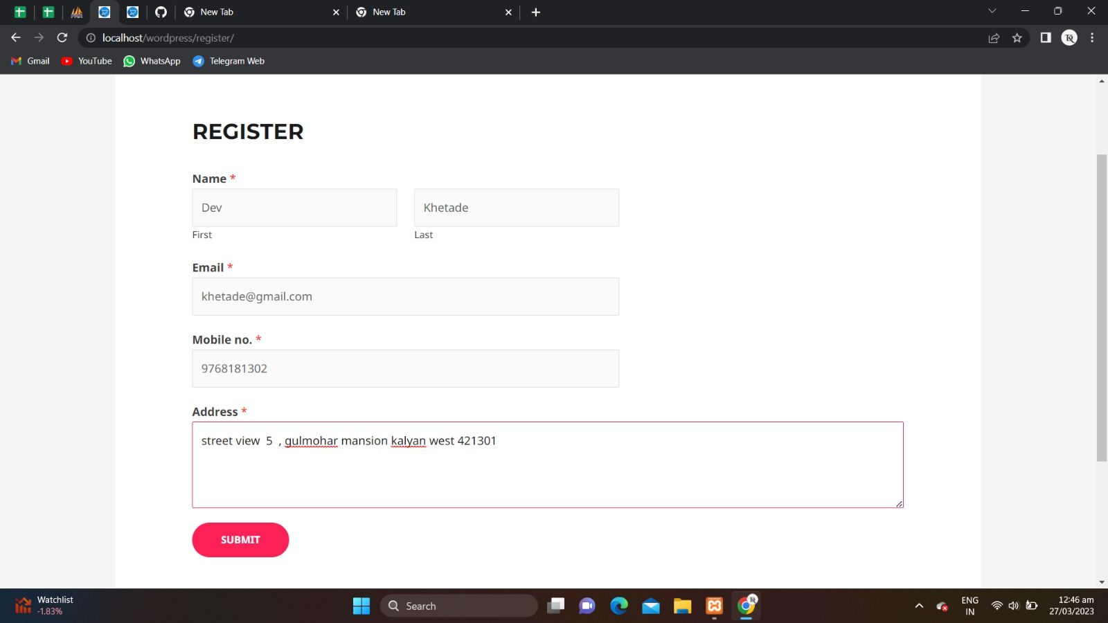

**Fig.5.12 Registration page**

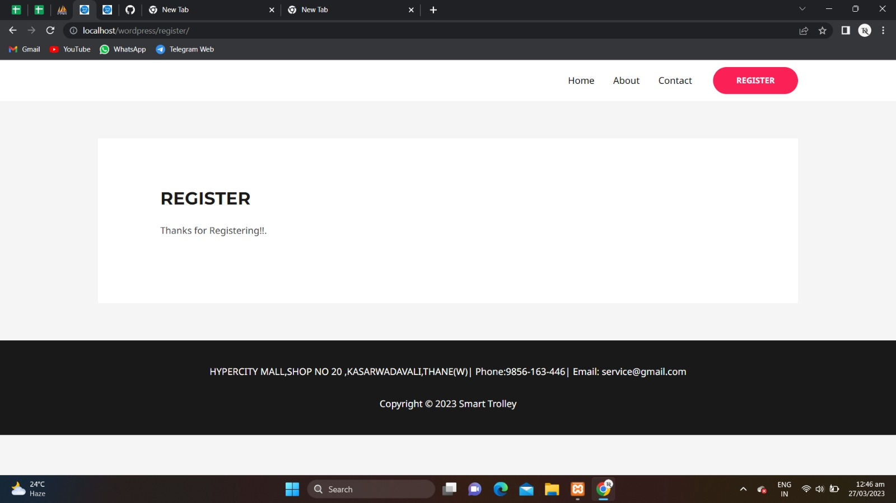

**Fig.5.13 Registration Successful**

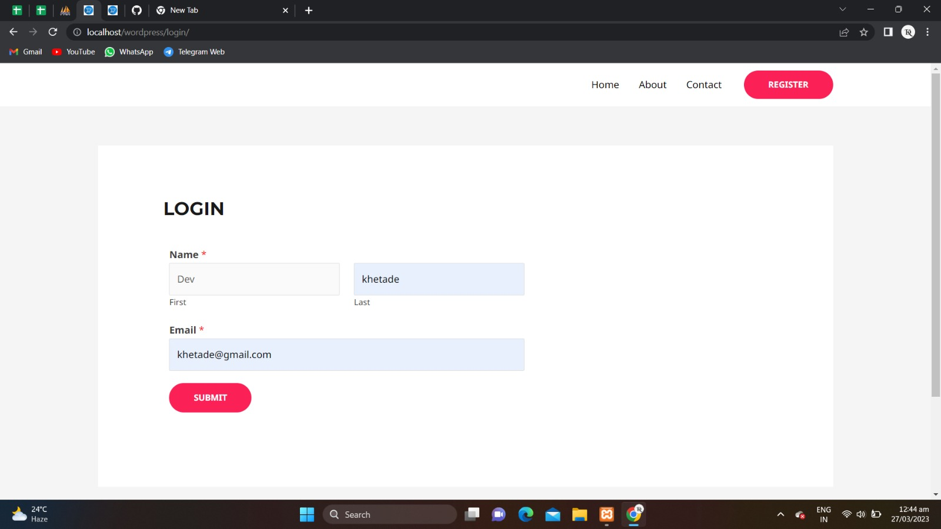

**Fig.5.14 Login Page**

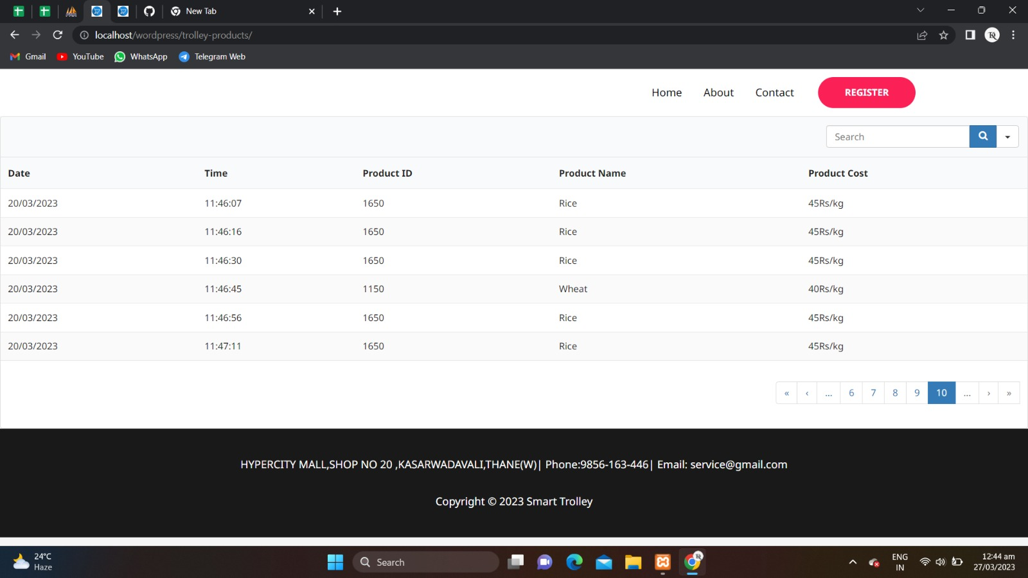

**Fig.5.15 Shopping List page**

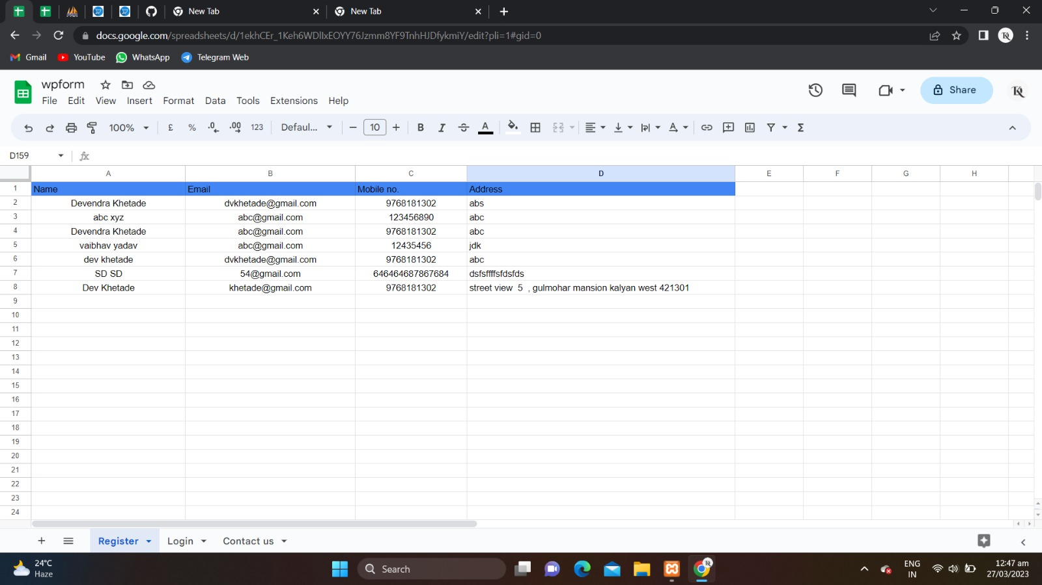

**Fig.5.16 Google sheet Register Page**

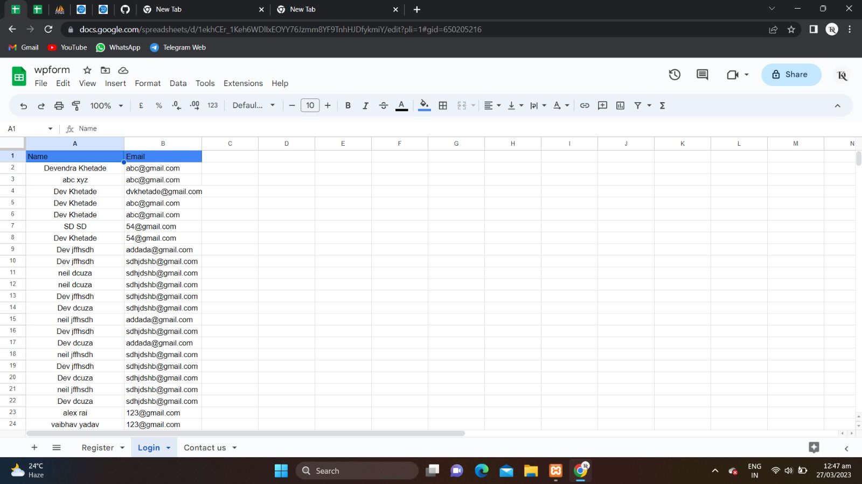

**Fig.5.17 Google sheet Login Page**

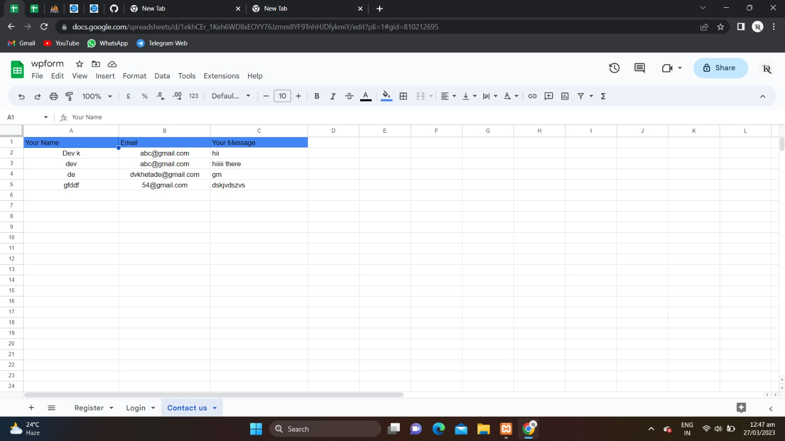

**Fig.5.18 Google sheet Contact Us Page**

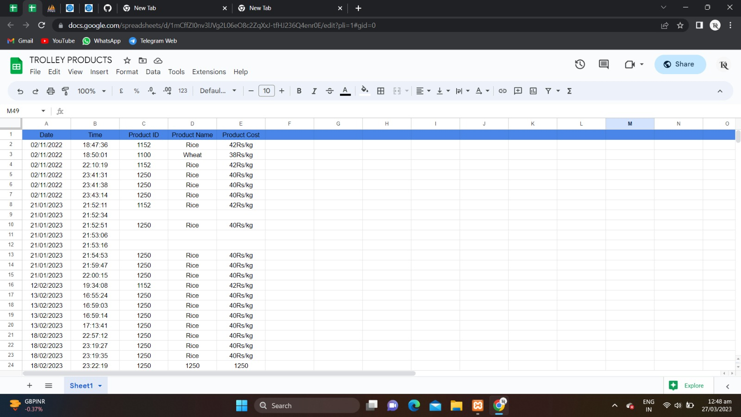

**Fig.5.19 Google sheet Final page**

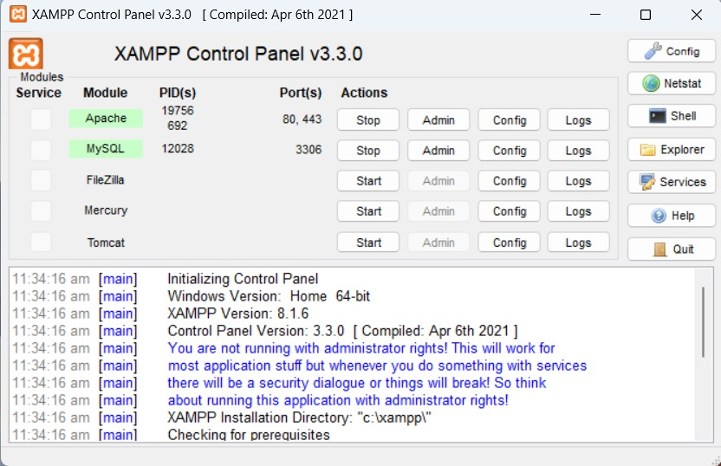

**Fig.5.20 Xampp control Panel**

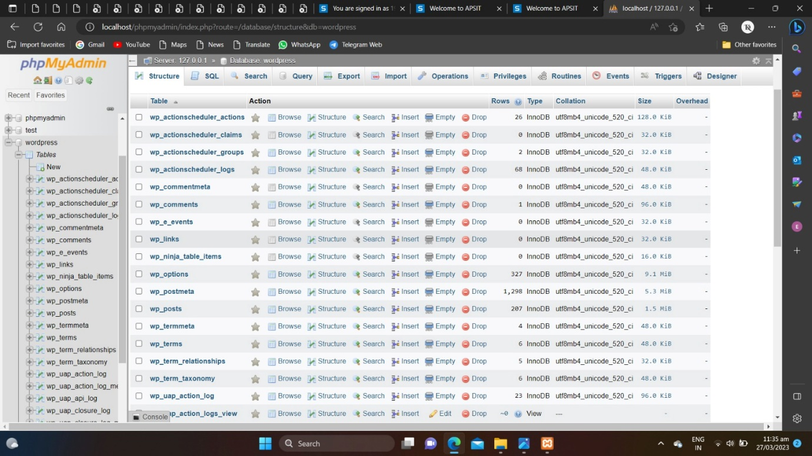

**Fig.5.21 Xampp Admin Page**

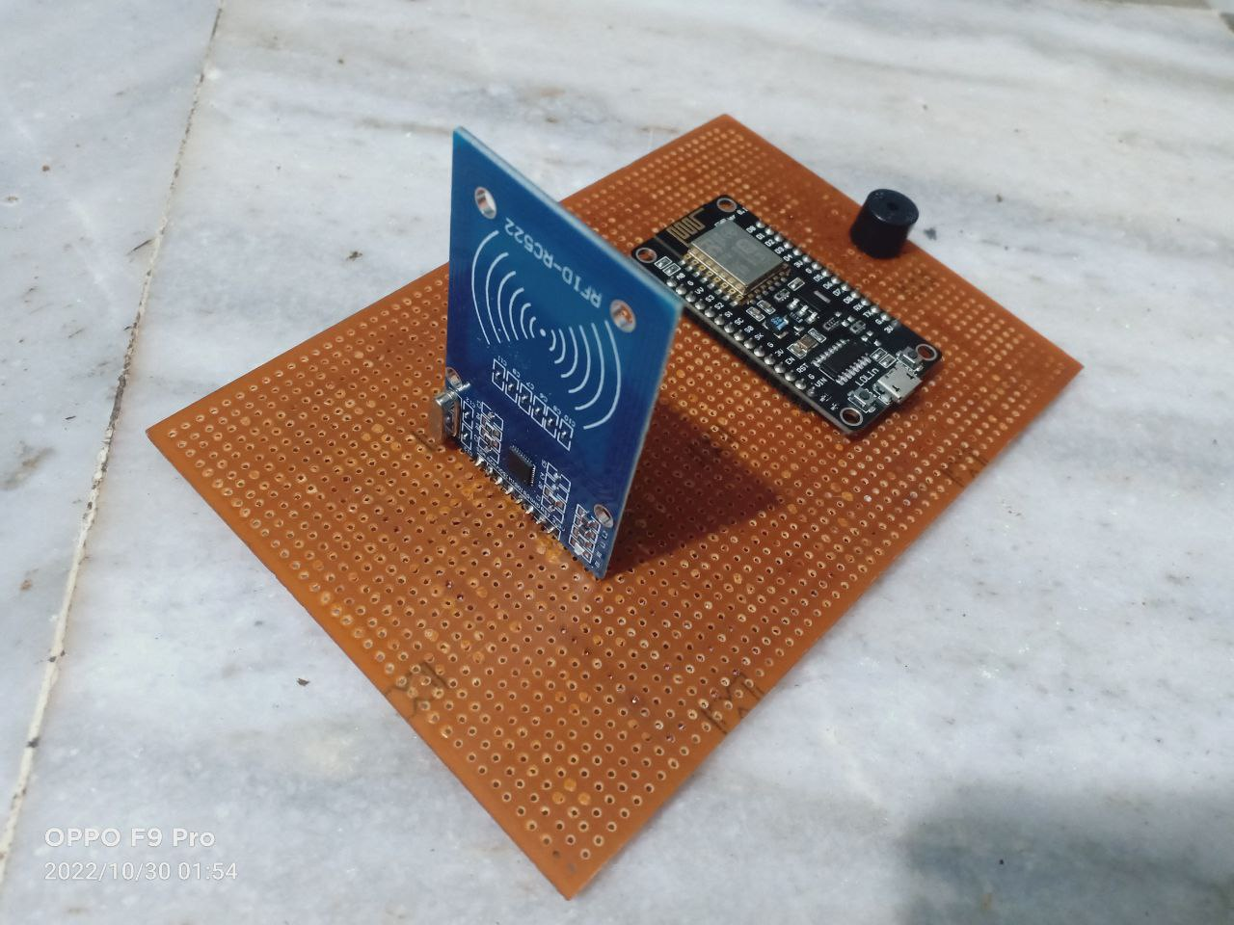

**Fig.5.22 Interfacing of Node MCU with RFID**

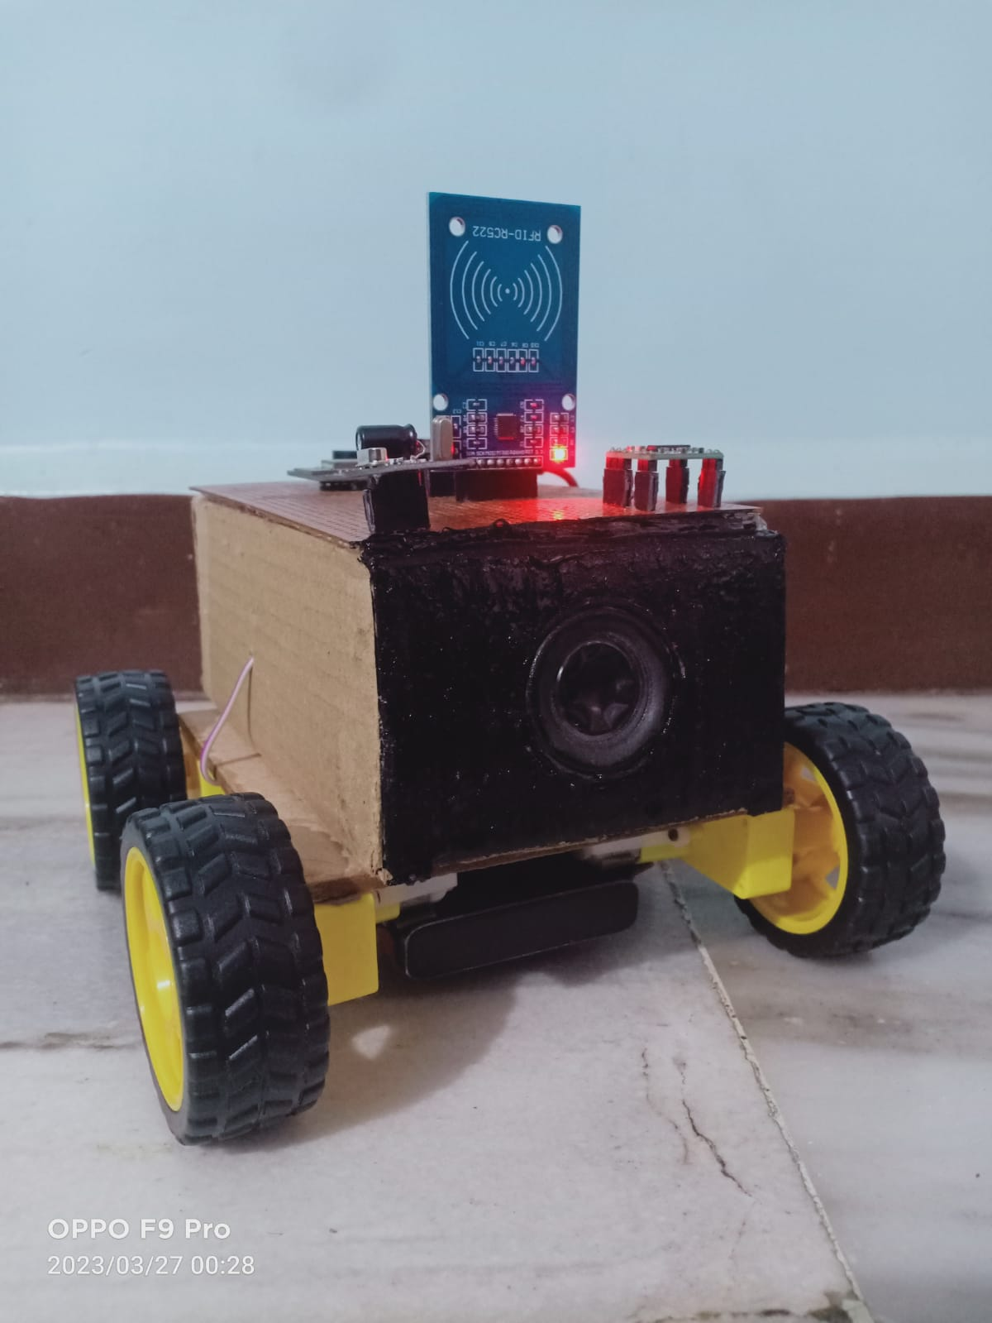

**Fig.5.23 Shopping cart front view**

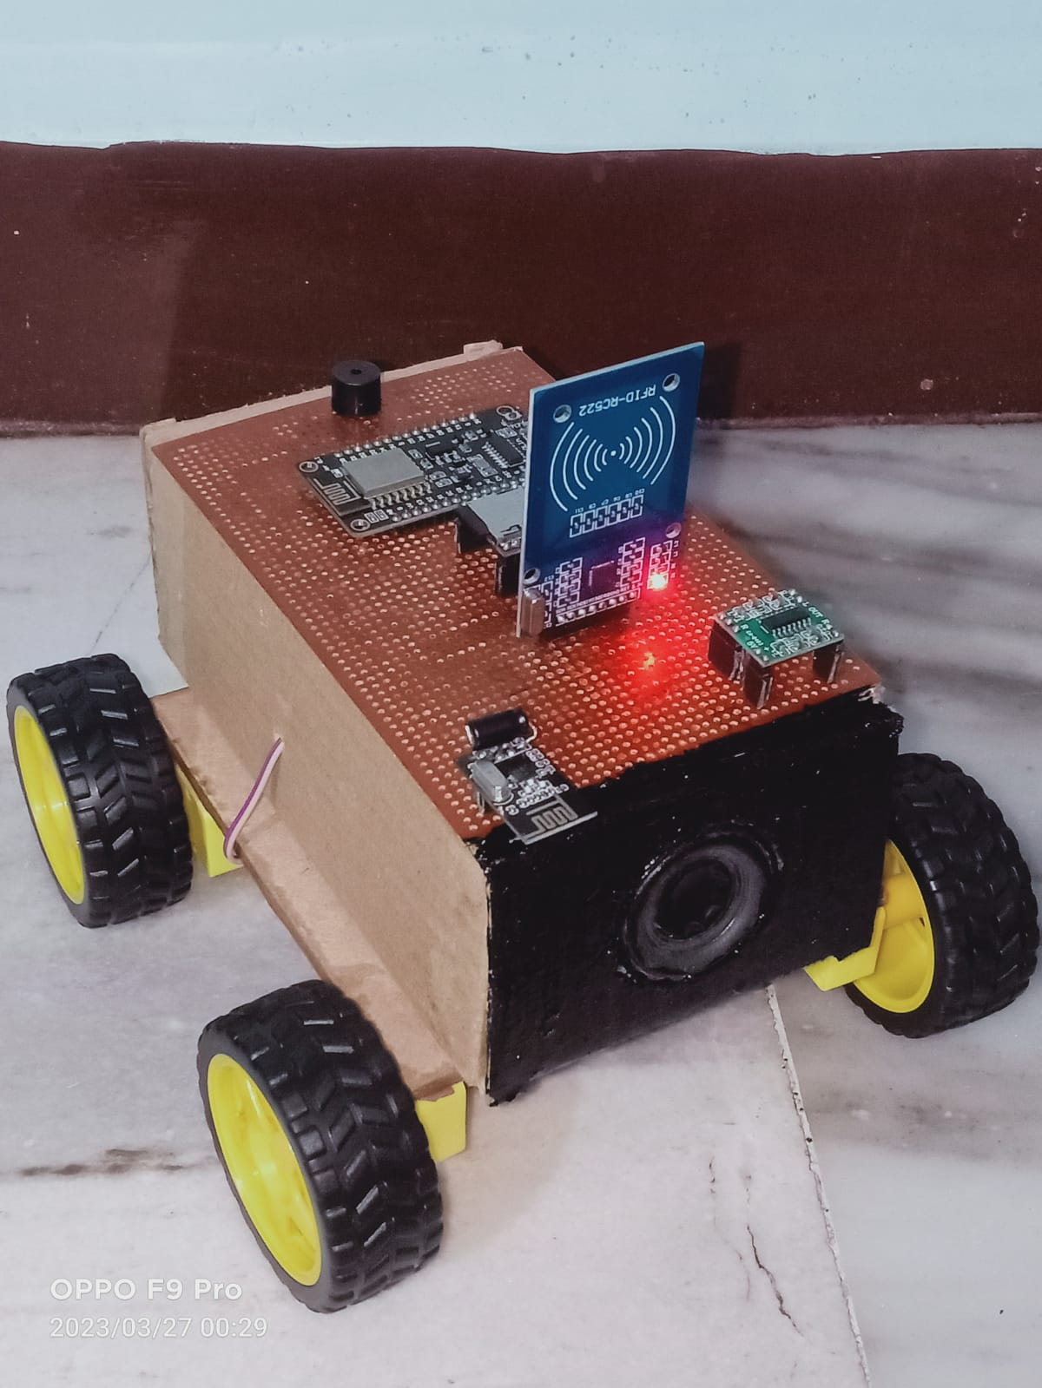

**Fig.5.24 Shopping cart Top view**

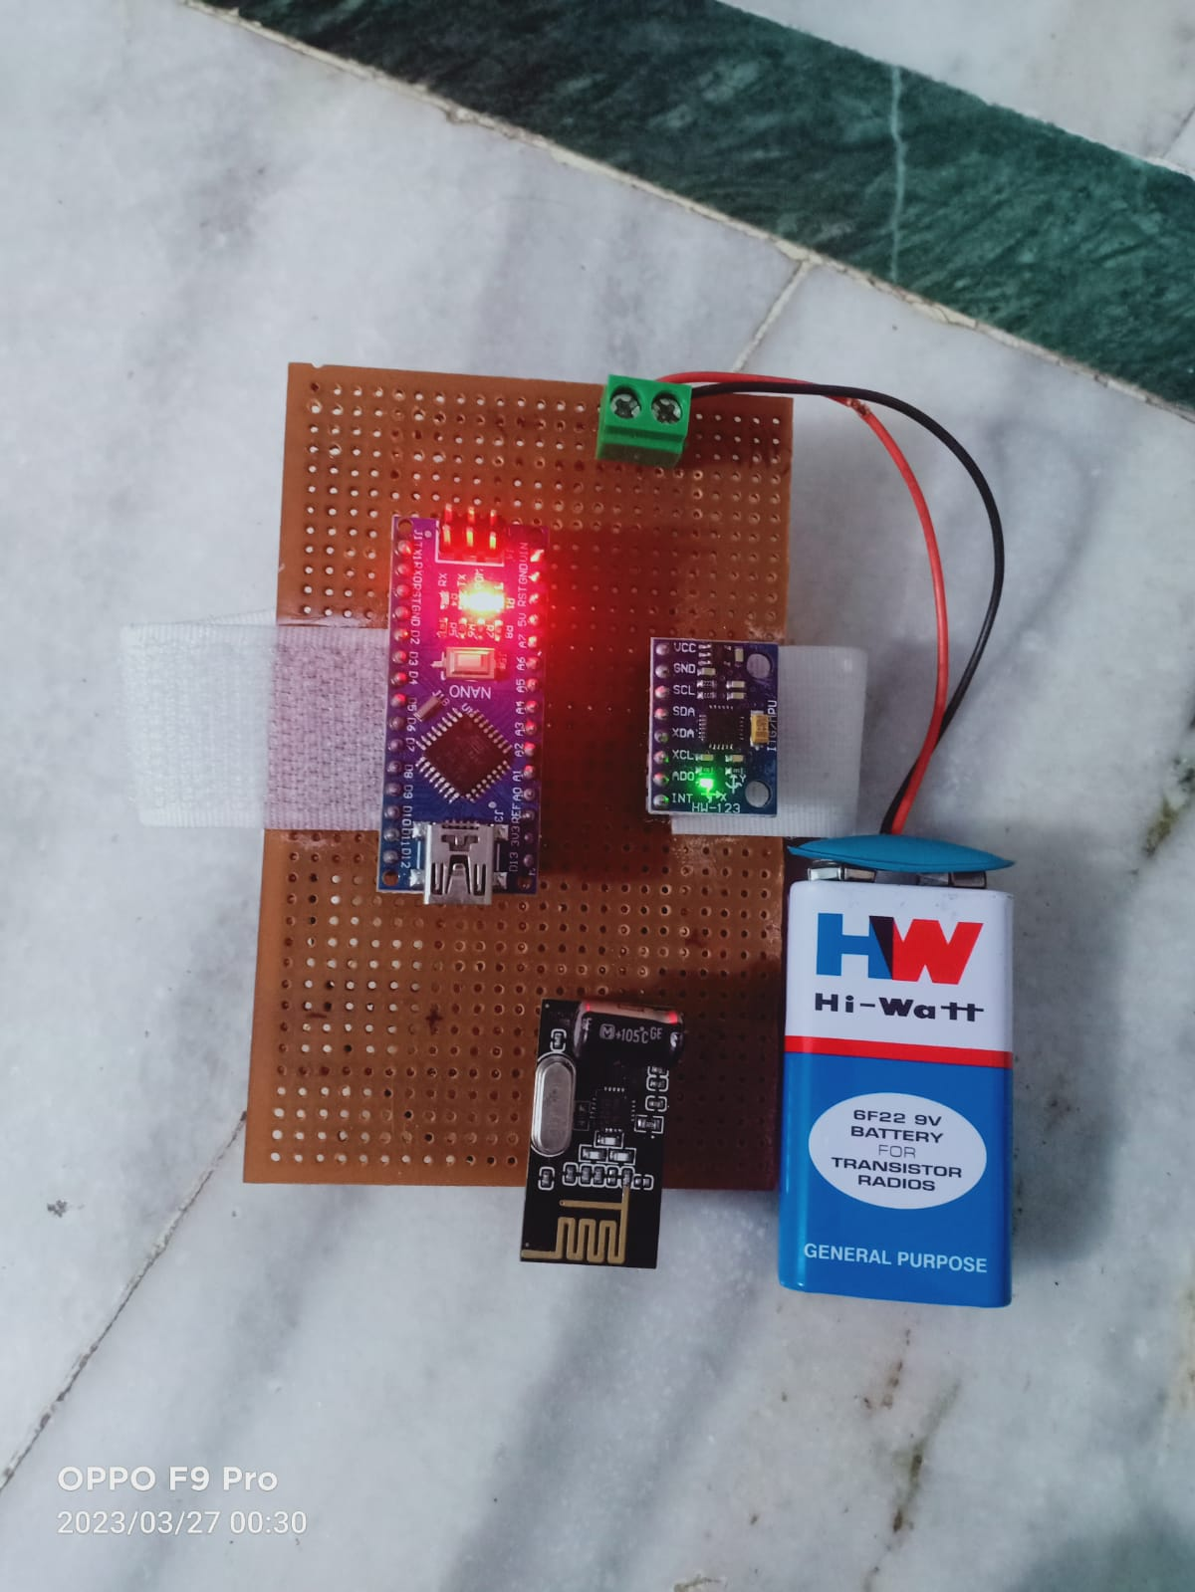

**Fig.5.23 Navigation Transmitter**

### CHAPTER 6

### CONCLUSION

### &

### FUTURE SCOPE

* 1. **Conclusion:**

We have seen the working of the entire smart trolley system & can understand from the set up that it is very user friendly. The voice assistance along with the item scanner gives proves to be very beneficial. For further assistance we can also look upto the navigation guide provided on the screen. The system integrates the trolley and your device seamlessly to your advantage saving a lot of time. It can be improved to new levels in future with more resources and time.

Hence, by using our most important component, the RFID system and the website which we have created work cohesively. In this thesis we explained everything about each component in detail. We have also explained the working with the practical usage in real world. This project be greatly reliable in future with the additional resources.

* 1. **Future Scope:**
* Development of project can be done in many ways, where RFID tags can be replaced by NFC tags which are small in size, low cost.
* Also, with the help of optical sensor, motors, and motor drivers, we will make trolley in such a way that it will follow the customer which purchasing items and it maintains the safe distance between customer and itself.
* Billing system can also be added, in order to show the final bill.

**Chapter 7**

**Reference**

### 7. REFERENCE

1. Prof. Sarala T, Prof. Sudha Y A, Prof. Sindhu K V, Prof. Suryakiran CH, Prof. Nithin B N Smart electronic trolley for shopping mall, 2018 3rd IEEE International Conference on Recent Trends in Electronics, Information & Communication Technology (RTEICT-2018), MAY 18th & 19th 2018, 2422-2427.
2. Prof.Tapan Kumar Das, Prof. Asis Kumar Tripathy, Prof. Kathiravan Srinivasan, A Smart Trolley for Smart Shopping, IEEE 2020, ISBN 978-1-7281-6202-7.
3. Prof. Mobeen Shahroz , Prof. Muhammad Faheem Mushtaq , Prof. Maqsood Ahmad, Saleem Ullah , Prof. Arif Mehmood, And Prof. Gyu Sang Choi IoT-Based Smart Shopping Cart Using Radio Frequency Identification, Received March 13, 2020, accepted April 5, 2020, date of publication April 8, 2020, date of current version April 22, 2020, VOLUME 8, 2020, 68426- 68438.
4. Prof. Mayur Sanap, Prof. Priya Chimurkar2, Prof. Narendra Bhagat, SMART-Smart Mobile Autonomous Robotic Trolley, Proceedings of the International Conference on Intelligent Computing and Control Systems (ICICCS 2020) IEEE Xplore Part Number:CFP20K74-ART; ISBN: 978-1-7281-4876-2,430-437.
5. Prof. Hanooja T, Prof. Raji C.G, Prof. Sreelekha M, Human Friendly Smart Trolley with Automatic Billing System, Fourth International Conference on Electronics, Communication and Aerospace Technology (ICECA-2020) IEEE Xplore Part Number: CFP20J88-ART; ISBN: 978-1-7281-6387-1, 1614-1619.
6. Prof. Shailesh, Prof. Pragati Shrivastav Deb, Prof. Ranjan Chauhan, Prof. Vaibhav Tyagi, Smart Trolley, 2021 International Conference on Advance Computing and Innovative Technologies in Engineering (ICACITE) Department of Electrical & Electronics Engineering, Galgotias College of Engineering and Technology. Gr. Noida, India,242-245.
7. M.Kabil Dev, R.Kannan, M.Agarshan , S.Karthik , Dr. K.Lakshmi, Automated Billing Smart Trolley and Stock Monitoring, Proceedings of the Fifth International Conference on Computing Methodologies and Communication (ICCMC 2021) IEEE Xplore Part Number: CFP21K25-ART,500-505.
8. Kowshika S, Madhu mitha S.S, Madhu Varshini G, Megha V, Lakshmi K, IoT based Smart Shopping Trolley with Mobile Cart Application, 2021 7th International Conference on Advanced Computing & Communication Systems (ICACCS), 978-1-6654-0521-8/21/$31.00 ©2021 IEEE,1186-118
9. <https://wordpress.com/hosting/?aff=15767&cid=1654213&cmp_id=11549382845&adg_id=111353876614&kwd=wordpress%20website&device=c>
10. <https://www.apachefriends.org/>
11. <https://youtu.be/97samwAA-TA>
12. <https://youtu.be/JdSzmSfxp_A>
13. <https://youtu.be/GlLRYml8mCY>
14. <https://youtu.be/-0HCNMU6KrM>
15. <https://youtu.be/-0HCNMU6KrM>
16. <https://youtu.be/hI0UBvpuRTw>
17. <https://youtu.be/-LKlx-2xGhs>
18. <https://youtu.be/AWpRGvP-9Lo>
19. <https://youtu.be/ai8-badNhXQ>
20. <https://youtu.be/0Z0nbb6DGck>